**17/05**

Testing grid format – Loaded website.

No current errors or issues. The text and colour needs to change (was using placeholder text)

Machine generated alternative text:
Banner 
Image 
Lorem ipsum dolor sit amet, consectetur adipiscing elit. 
Nam eget metus purus. 
nav I nav I nav I nav I nav I nav I nav 
Lorem ipsum dolor sit amet, consectetur adipiscing elit. 
Nam eget metus purus. 
Logo 
Lorem ipsum dolor sit amet, consectetur adipiscing elit. 
Nam eget metus purus. 
O Logan Purvis, 2019 

**19/05**

Half-way through Index page – Validated CSS and HTML and loaded website to make sure it worked.

No issues found.





Nat 
null null n 
Random Facts! 
Welcome to the home-page of the Random Facts website! Click one of the three links down below to learn something new! 
Technology 
null null nullnull null 
O Logan Purvis, 2019 

**21/05**

Index page finished - Validated CSS and HTML.

No issues found.





**21/05**

Header/Nav and Footer files separated into separate .html files for convenience. Validated CSS and HTML.

Issues found with the **doctype**. Resolved this quickly by removing it from the footer and adding to the header/nav section.

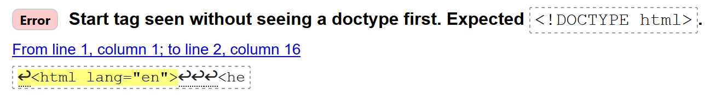

After fixing issue:

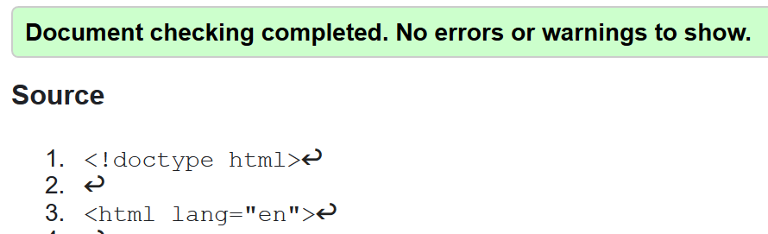

**23/05**

Midway through Nature page – Validated CSS and HTML and loaded website.

No issues found.

Machine generated alternative text:
There are 12 times more trees on 
Earth than stars in the Milky Way. 
Scientists estimate there are between 200 - 400 billion 
stars in our galaxy while there are an estimated 1 
trillion trees on Earth. 
Cows kill more people than sharks. 
Sharks kill an average of 5 people per year while cows 
kill an average of 22 people per year. 
Pluto hasn't made a full orbit around the 
sun since it was discovered. 
Pluto's discovery was on February 18, 1930. It hasn't made a full orbit 
of the sun since that time because of its incredibly slow orbit. It takes 
Pluto 248.09 years to make one orbit around the sun, this means that 
Pluto will make its first full orbit since 1930 on March 23, 2178 





**24/05**

Nature page completed (images inserted) – Loaded website

No issues

There are 12 times more trees on 
Earth than stars in the Milky Way. 
Scientists estimate there are between 200 - 400 billion 
stars in our galaxywhile there are an estimated 1 
trillion trees on Earth. 
Cows kill more people than sharks. 
Sharks kill an average of 5 people peryear Wbite cows 
kill an average of 22 people per year. 
't made a full orbit around the 
Pluto 
ce it was discovered. 
su 
's Iscöverywas on February 18, 1930. It inadéa full orbit 
sun since that time because of its incrediblvslow orbit. It takes 
I o, .09 years to make pne orbit aroun< the sun,rthis means that 
it since 1930 onwarch 23, 2178 

**26/05**

History page halfway – Validated HTML and CSS

Issues with the internal stylesheet. This was fixed easily - the <style> tags were reversed (</style> at the beginning and <style> at the end.)

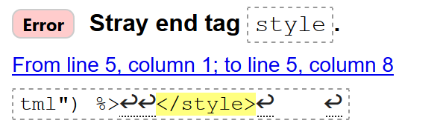

After validating:



**28/05**

History page completed – Loaded website

No errors.

Machine generated alternative text:
Napoleon was once attacked by a 
horde of bunnies. 
Napoleon had requested that a rabbit hunt be 
arranged for himself and his men. His chief of staff set 
it up and had men round up reportedly 3000 rabbits 
for the occasion. When the rabbits were released from 
their cages, the bunnies charged toward him and his 
men in a viscous and unstoppable onslaught. 
There were more than 600 plots to 
kill Fidel Castro 
The Cuban dictator was targeted to be killed by a large 
range of foes, •ncluding political opponents, criminals, 
and even the united States. Tactics included 
everything from ane Odin 
The Wright Brothers did not inv 
aeroplane. 
In March of 1902, the New Zealand 
yards (by most eyewitness qcc Q 
crashing into a hedge. Thi i 
months before the Wr• tbrgtti 
Ookflight fo 
in monoplan 
rc 
p låCév•,. 
e*pefim t 
re sus ned 

**30/05**

Midway through Technology page – Tested HTML and CSS

No errors





**1/06**

Technology page finished – Loaded website

One image was slightly too large. I decreased the image size on fact 1 to 650px from 700. The text on fact 3 was too dark to read so I changed this to white.

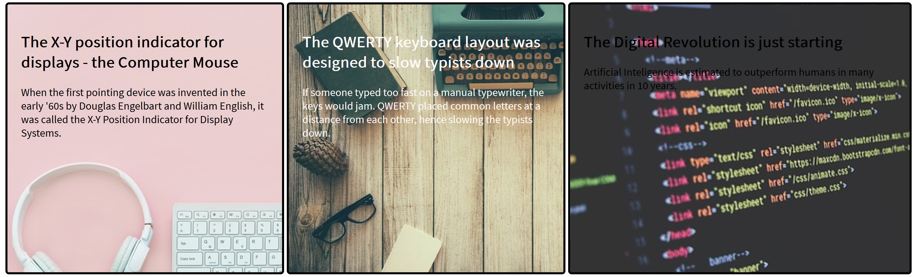

After:

